This is the story page how it looks like at the moment for not logged in users.

This part at the top is for “experiencing” the stories

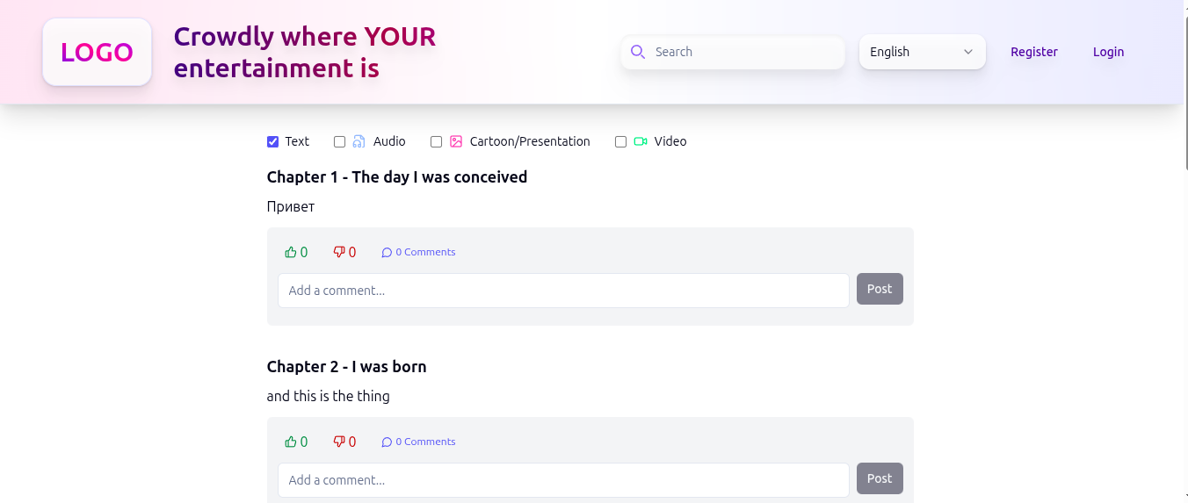

This part below is for (co-)creating them. Ideally they should be separated from each other with a something like “I want to contribute to the story” button placed (where to place it best??? right upper or left upper corner????). Once the user clicked on the button, the part below would become visible to the potential contributor.

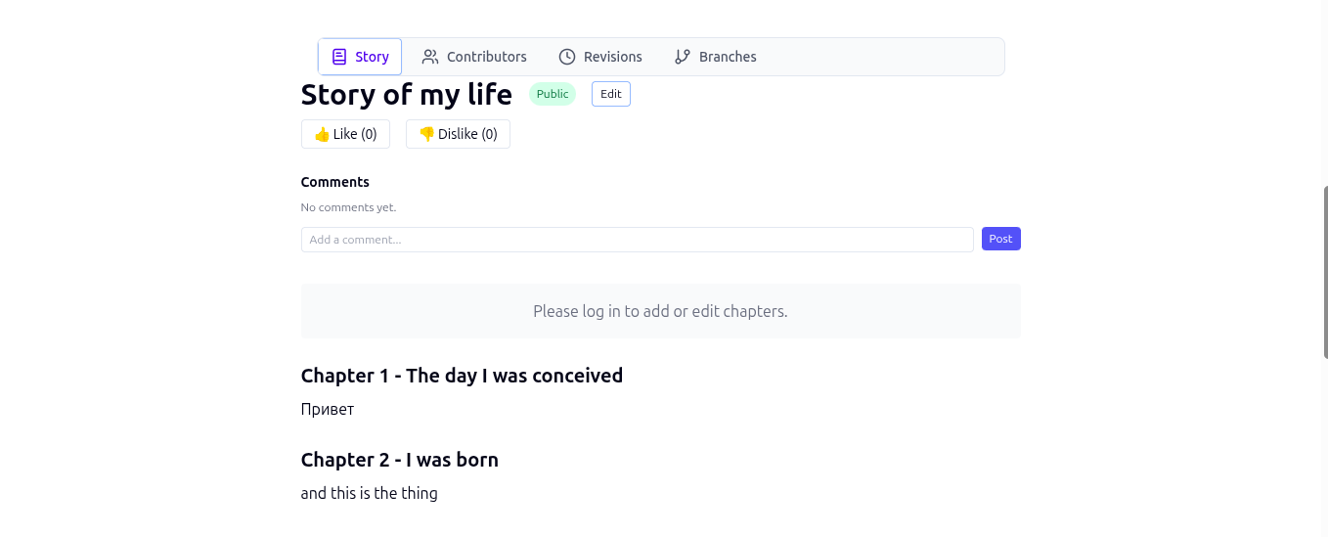

In this view there also has to be a button “Back to experiencing the story”
Again, right top corner of the body or left top corner of the body???

And I would love this (co-)creating part to look minimalistic (like on the screenshot below) and when I point the story title, chapter title with the mouse it should give me the pop-menu with the controls: (on touch screen devices I need to make long touch i.e. touch and hold to get the menu)

Click onto story title, chapter name – and it becomes editable
Drive over them (tab and hold on touch screen devices) – gives the menu / control elements
Browsing away / clicking away – saves changes (if any were made)
Double click – and you browse to the link location
Drive over the story text / paragraph with a mouse (like in the screenshots below) – it offers you to create a branch (like in the screenshots below)

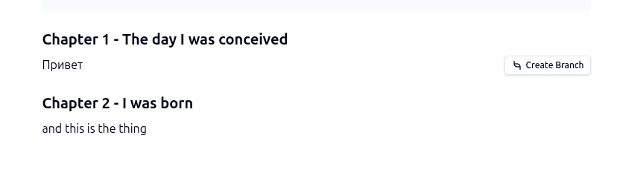
Chapters can also be opened as a new web page

story/’story_id’/chapter/’chapter_id’

or something similar

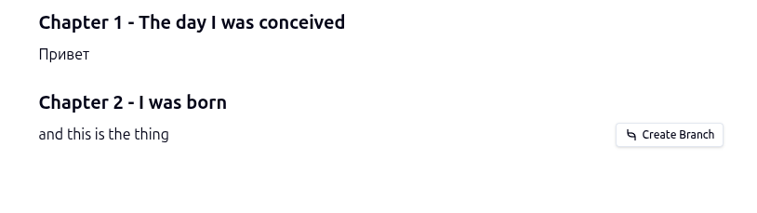
What creating of a branch looks like?
It just makes a new line below the paragraph for entering text, which will have branch and tags it as a branch and where (co-)creator can enter his / her text content

That’s why I have this “Enable Editing Mode” button (s. the screenshot below) when logged either as a user with admin or support rights, because the idea was that such users (with with admin or support rights), could immediately translate the elements of the web platform into various language versions of the platform and contribute to the stories, etc

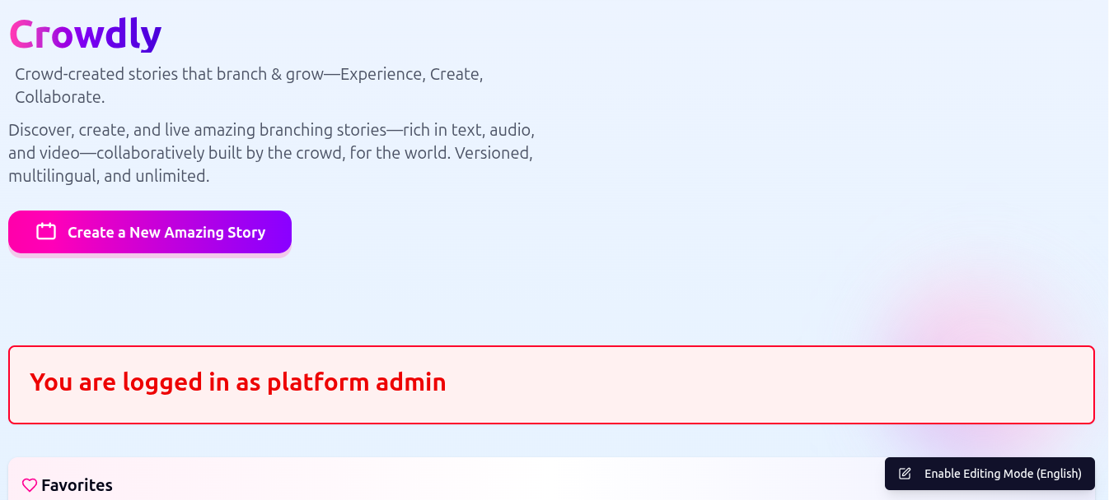

That’s why we have the language switch at the top of the web platform.

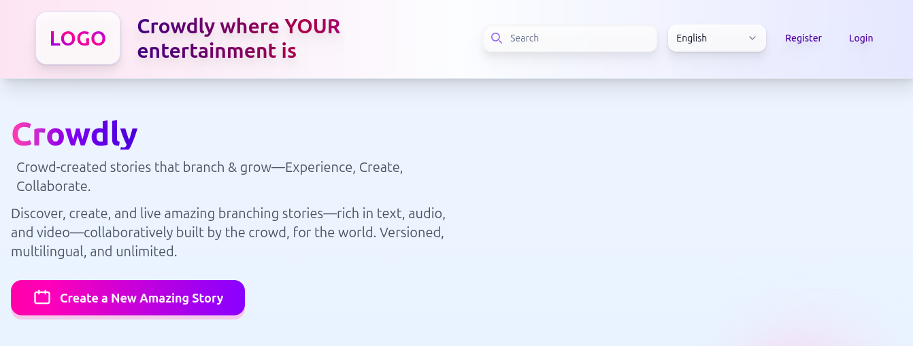

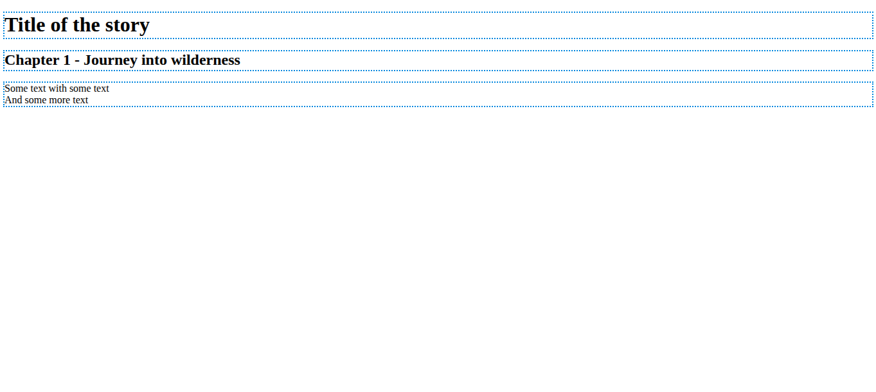
In the next tab, which is called “web editor” we implemented Aloha Editor into an almost empty page.

Aloha Editor unfortunately is not ideal as it doesn't support a bunch of HTML elements such as e.g. img, etc; but I pretty much like the idea of it.

The list of not supported elements is on the link below (at the very bottom of the document)

https://www.alohaeditor.org/guides/using_aloha.html

That’s why we will improve it for using on Crowdly web platform with a better improved functionality.

